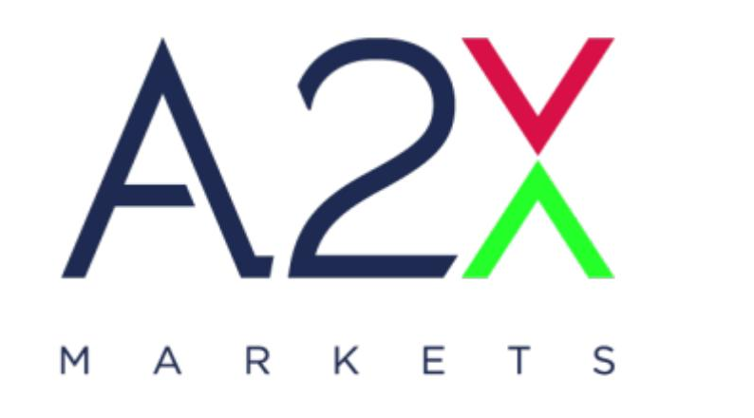
A2X Member Test Environment Sign-Off
October 2026
Version 1.0
Platform upgrade – Aquis MTF software
A2X MARKETS

A2X Markets is an exchange licensed in terms of the Financial Markets Act, 2012

1 Purpose
This document records a member firm’s confirmation that it has successfully exercised its current production order and market data flow against the A2X Member Test Environment running the upgraded A2X trading platform. It is to be completed and returned by each member firm before that firm is scheduled for production cutover.
Sign-off confirms that the member’s existing production behaviour has been reproduced end to end on the new platform, that any protocol changes affecting that behaviour have been implemented, and that the member is satisfied that no regression has been introduced by the upgrade.
Completion of this document does not replace conformance testing. Members must complete the applicable conformance or certification scenarios in addition to the regression confirmation recorded here.

2 Scope
The upgrade affects the three client-facing protocol layers set out below. A member is required to sign off against the protocols it uses in production.

Protocol | Current production version | Upgraded version | Reference specification
FIX 4.2 | A2X FIX 4.2 Specification v2.0 | FIX v4.2 version 3 | A2X FIX 4.2 Specification, August 2026
Binary (ATP) | A2X Binary Protocol (ATP) v2.9.2 | ATP v2.11.1 | A2X Binary Protocol (ATP) Specification v2.11.1
Market Data | A2X Market Data Specification v1.3.2 | Market Data v2.5 | A2X Market Data Technical Specification v2.5
Drop Copy | As per FIX 4.2 v2.0 | As per FIX v4.2 Version 3 | A2X FIX Drop Copy Summary of Changes v1.0

3 Member Details
To be completed by the member firm.

Field | Detail
Member firm
Trading system / vendor platform and version
Protocols in scope (FIX / ATP / Market Data / Drop Copy)
Test environment CompIDs or session identifiers
Testing period (from – to)
Primary technical contact (name, email, telephone)

4 Production Flow Verification
The member confirms that each applicable item below has been exercised in the A2X Member Test Environment using the same application, configuration and operational process used in production today, and that the observed behaviour was correct. Items that do not form part of the member’s production flow are to be marked not applicable.

Ref | Area | Verification | Result | Date and tester
1.1 | Session | Logon, heartbeat, test request and logout complete normally on all production sessions.
1.2 | Session | Sequence number handling, resend request and gap fill behave as in production.
1.3 | Session | Recovery after disconnect, including cancel on disconnect where configured.
2.1 | Order entry | All order types, time in force and order capacity values used in production are accepted.
2.2 | Order entry | Order modification and cancellation produce the expected acknowledgements.
2.3 | Order entry | Rejections are received, parsed and surfaced correctly by the member system.
2.4 | Executions | Full and partial fills, and the resulting position and order state, match production behaviour.
2.5 | Executions | Trade cancellation (bust) is received and processed correctly.
3.1 | Auctions | Opening, closing and Market at Close auction participation behaves as expected.
3.2 | Auctions | Auction on Demand flow, where used in production, behaves as expected.
4.1 | Trade reporting | Trade capture reports used in production are accepted and acknowledged.
5.1 | Market data | Feed connection, snapshot recovery and sequence gap handling operate correctly.
5.2 | Market data | Instrument reference data, order book and trade messages are decoded correctly.
6.1 | Drop copy | Drop copy sessions deliver the expected messages to downstream systems.
7.1 | Downstream | Back office, risk and reconciliation files produced from the test session are correct.
8.1 | End of day | A full trading day was completed without unexplained disconnection or error.

Result: enter Pass, Fail or N/A. Any item marked Fail must be listed in section 5.

5 Exceptions and Outstanding Items
List any item that did not pass, any behaviour that differs from production, and any item deferred by agreement with A2X. Enter “None” where there are no exceptions.

Ref | Description | Agreed action | Target date

6 Declaration
By signing below, the member firm confirms that:
- its current production order, execution, market data and downstream flow has been tested against the A2X Member Test Environment on the upgraded platform;
- the applicable items in section 4 have been exercised and the observed behaviour was correct, other than the exceptions recorded in section 5;
- all protocol changes affecting its production flow have been implemented in the systems that will connect to production;
- the systems and versions tested are those that will be used at production cutover; and
- the firm is ready to be scheduled for cutover to the upgraded platform.

Member firm
Role | Name | Signature | Date
Technical lead
Head of trading or delegate
Compliance or operations

A2X Markets
Role | Name | Signature | Date
Technical operations
Market operations

7 Return and Enquiries
Return the completed and signed document to the A2X support team at support@a2x.co.za. Enquiries relating to the test environment, scheduling of interactive test cases or the content of this document should be directed to the same address.

